An Assignment of

**Module -4 Automation Core Testing**

**(Load Runner Up and Selenium IDE)**

Submitted to

Chinmayee Shukla Ma’am

Tops Technologies Ahmedabad – S G Road



By

Piyush Dabhi

August 2024

1. **Which Component have you used in Load Runner?**

There are three components mainly used in Load Runner which is as bellow,

1. **VUGen** – **Virtual User Generator -** It will allow you to record and replay script. And allow you to enhance your script.
2. **Controller -** It will allow you to design the scenarios and execute the test with multiple users.
3. **Analyzer -** It will allow to analyse the statistics and finding out the bottlenecks

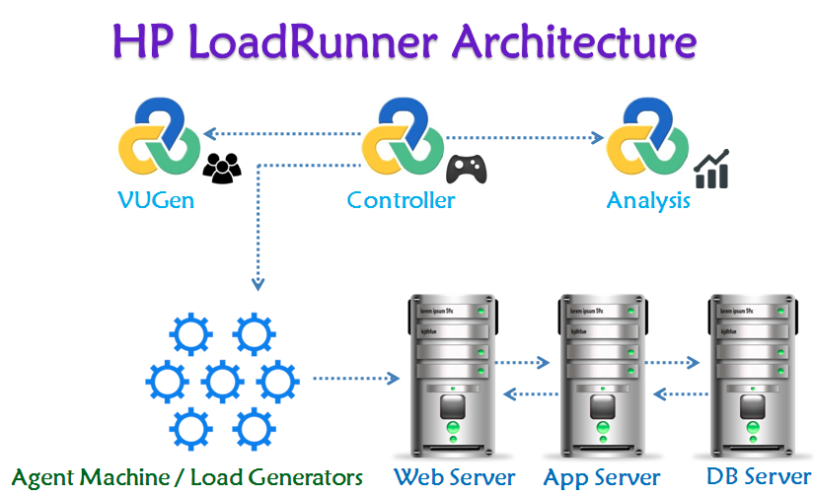

1. **How can you set the number of Vusers in Load Runner?**

There are number of steps to set the Vuser in Load Runner as bellow,

**Step 1** - Open LoadRunner Controller: Start the LoadRunner Controller application.

**Step 2** - Create a New Scenario or Open an Existing One:

**Step 3** - Add Vuser Scripts: In the Controller, you need to add the scripts you have created in VuGen

**Step 4** - Scenario Configuration: Select the script or scripts you want to configure.

**Step 5** - Specify Vuser Count: In the "Scenario Configuration" pane, you will see an option to set the number of Vusers.

**Step 6** - Define Load Generators: If you have multiple Load Generators (machines where the Vusers will run), you can specify how the Vusers should be distributed across these generators.

**Step 7** - Set Test Duration: You can configure how long the test should run and any ramp-up or ramp-down periods.

**Step 8** - Schedule the Test: Use the scheduling options to define when the test should start and stop.

**Step 9** - Save: Save your scenario configuration to ensure that all your settings are preserved.

**Step 10** - Run: Execute the test scenario to start the performance testing with the configured number of Vusers.

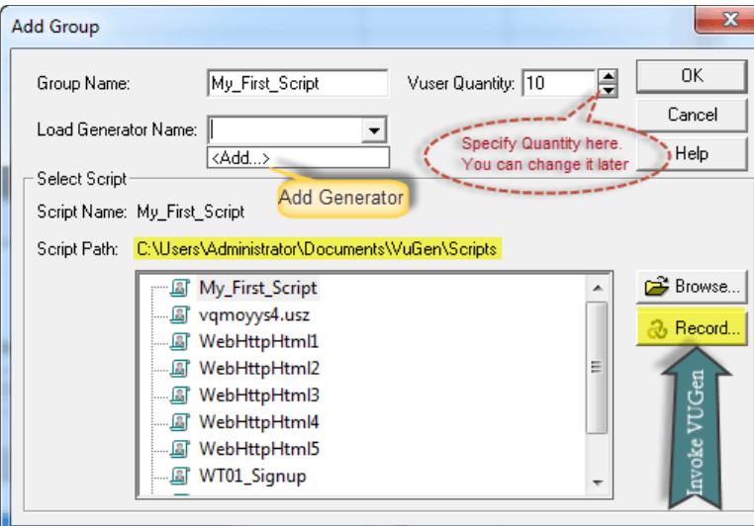

1. **What is Correlation?**

Correlation is the concept to handle the dynamic values which are generating from server side. (Or) Dynamic input to the server. You can conduct the correlation in 2 ways:

1. Auto Correlation.  
2. Manual Correlation.

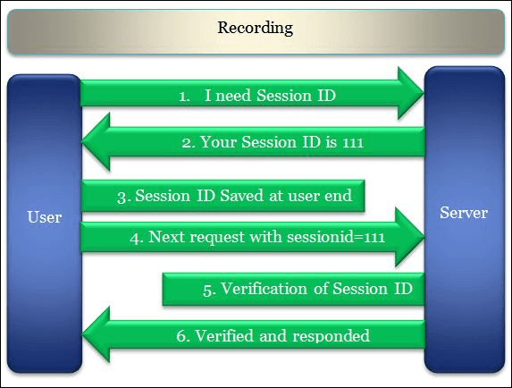

1. **What is the process for developing a Vuser Script?**

There are number of steps to develop Vuser Script as bellow,

**Step1** - recording the vuser script.  
**Step 2** - edit the vuser script.  
**Step 3** - runtime setting.  
**Step 4** - run the vuser script in stand-alone mode.  
**Step 5** - incorporate the vuser script into a load runner scenario.



1. **How Load Runner interects with the application?**

LoadRunner interacts with applications primarily through its protocols and components designed to simulate user interactions and gather performance metrics. Here’s a detailed explanation of how LoadRunner interacts with applications:

* Protocols and Scripting
* Recording and Playback
* Virtual User Actions
* Parameterization and Correlation
* Load Generation
* Monitoring and Analysis
* Error Handling and Validation
* Integration with Other Tools

1. **How many Vusers are required for Load testing?**

One of the most common questions we get is "how many virtual users do I need to simulate?" The obvious answer is "how many people do you expect to have

accessing the your system simultaneously?". If you have this information, then you're done! For more details,

* **Peak Hourly Visits and Average Visit Length**

If you know the peak hourly visit rate (the number of unique visitors to the website in its busiest hour) and the average visit length (the amount of time, on average, each use spends on the website), enter them below for an estimate of the required Virtual User count.

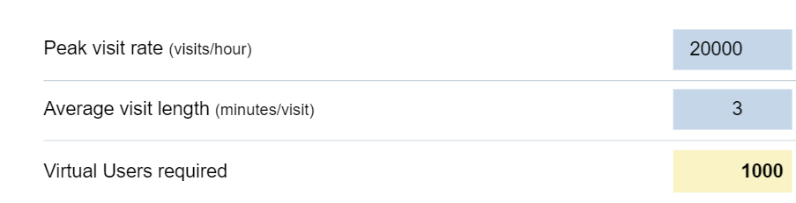

* **Peak Hourly Pages, Testcase Size and Duration**

If you know the peak hourly page rate (the number of pages visited on the website in its busiest hour) and the size and duration of the testcase (number of pages and duration in minutes), enter them below for an estimate of the required Virtual User count.

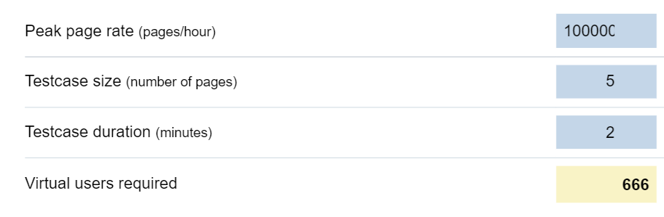

1. **What is relationship between Response time and Throughput?**

Response Time (latency): The time between the start and completion of task.

Througput (Bandwidth): The total amount of work in given time,

* **Relationship Between Response Time and Throughput**

1. **Inverse Relationship:** Generally, there is an inverse relationship between response time and throughput. As the number of concurrent users or load increases, the application may take longer to process each request, causing an increase in response time. Conversely, if the application is under a lighter load, it may process requests more quickly, resulting in lower response times.
2. **Capacity and Performance**: Throughput helps determine the application's capacity. If throughput is high, it means the application can handle a large number of requests. However, if throughput increases beyond the system’s capacity, response times will typically increase as the application struggles to manage the load.
3. **Performance Bottlenecks**: High response times at high throughput levels often indicate performance bottlenecks, such as insufficient server resources, database contention, or network latency. Optimizing the application to handle higher throughput while maintaining acceptable response times is crucial for performance tuning.
4. **Scaling Implications**: When scaling applications, understanding the relationship between response time and throughput is essential. You might need to balance these metrics by optimizing the application, upgrading infrastructure, or distributing the load to achieve desired performance levels.

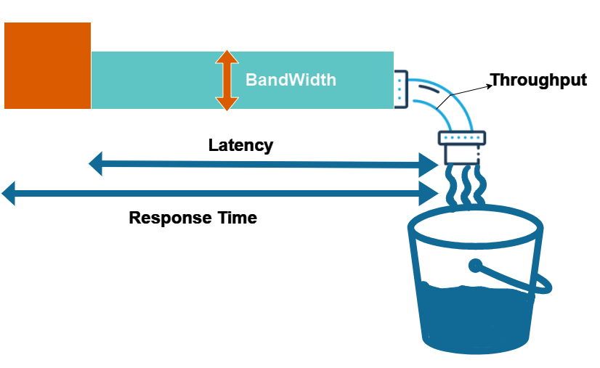

1. **What is Automation Testing?**

It’s a technique where the Tester writes scripts independently and uses suitable Software or Automation tools test the software. It is an Automation Process of a Manual Process. It allows for executing repetitive tasks without the intervention of a Manual Tester.

* It is used to automate the testing tasks that are difficult to perform manually.
* Automation tests can be run at any time of the day as they use scripted sequences to examine the software.
* Automation tests can also enter test data compare the expected result with the actual result and generate detailed test reports.
* The goal of automation tests is to reduce the number of test cases to be executed manually but not to eliminate manual testing.
* It is possible to record the test suit and replay it when required.

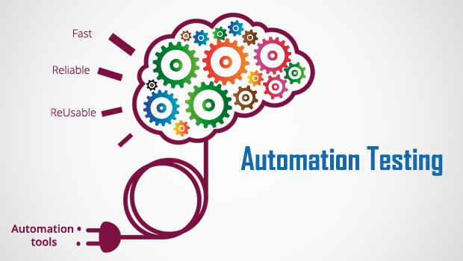

1. **Which are the browsers supported by Selenium IDE?**

Selenium IDE (Integrated Development Environment) is a browser extension used for automating web applications. Currently browser supported are as bellow,

* Firefox
* Chrome
* Edge
* Safari

1. **What are the benefits of Automation Testing?**

* **Simplifies Test Case Execution**: Automation testing can be left virtually unattended and thus it allows monitoring of the results at the end of the process. Thus, simplifying the overall test execution and increasing the efficiency of the application.
* **Improves Reliability of Tests:** Automation testing ensures that there is equal focus on all the areas of the testing, thus ensuring the best quality end product.
* **Increases amount of test coverage:** Using automation testing, more test cases can be created and executed for the application under test. Thus, resulting in higher test coverage and the detection of more bugs. This allows for the testing of more complex applications and more features can be tested.
* **Minimizing Human Interaction**: In automation testing, everything is automated from test case creationto execution thus there are no changes for human error due to neglect. This reduces the necessity for fixing glitches in the post-release phase.
* **Saves Time and Money**: The initial investment for automation testing is on the higher side but it is cost-efficient and time-efficient in the long run. This is due to the reduction in the amount of time required for test case creation and execution which contributes to the high quality of work.
* **Earlier detection of defects**:  Automation testing documents the defects, thus making it easier for the development team to fix the defect and give a faster output. The earlier the defect is identified, the easier and more cost-efficient it is to fix the defects.

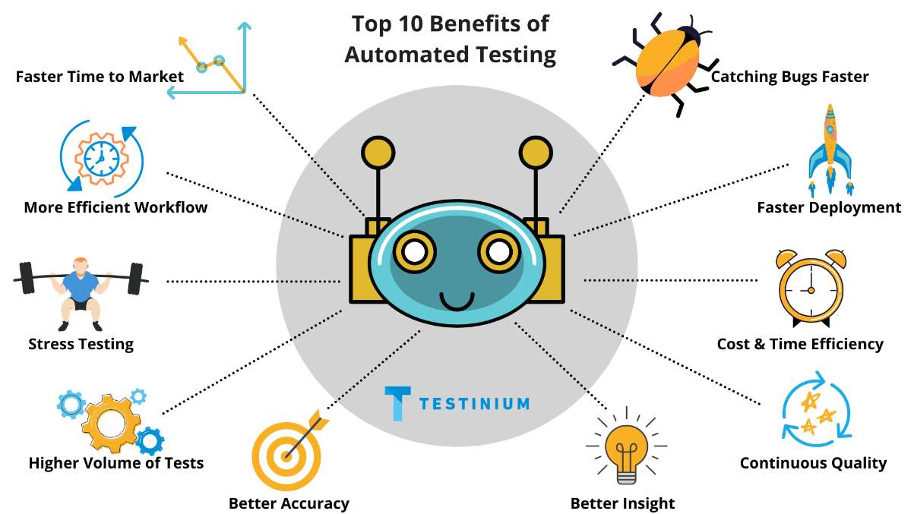

1. **What are the advantages of Selenium?**

* **Cross-Browser Compatibility:** Selenium supports multiple browsers like Chrome, Firefox, Safari, and Internet Explorer, making it easier to test web applications on different platforms.
* **Platform Independence:** Selenium is a cross-platform tool, which means it can be used on different operating systems like Windows, Linux, and macOS.
* **Support for Multiple Programming Languages:** Selenium supports multiple programming languages, including Java, C#, Python, Ruby, and others. This allows developers and testers to choose the language they are most comfortable with.
* **Large Community and Resources:** Selenium has a large and active community. This means there is a wealth of documentation, tutorials, and forums available, making it easier for users to find help and solutions to common problems.
* **Integration with Other Tools:** Selenium can be easily integrated with other tools and frameworks, such as TestNG, JUnit, Maven, and Jenkins, enhancing its capabilities and making it suitable for various testing needs.
* **Flexibility and Extensibility:** Selenium can be extended for various functionalities through its APIs, making it adaptable to different testing scenarios.
* **Support for Parallel Execution:** Selenium allows for the parallel execution of test scripts, which can significantly reduce the overall test execution time.

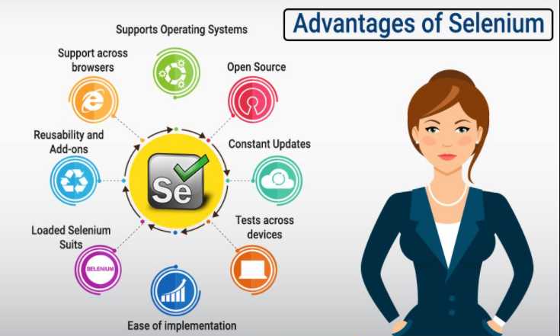

1. **Why Tester should opt for Selenium and not QTP?**

Testers might opt for Selenium over QTP/UFT for several reasons:

* **Cost-effectiveness:** Selenium is free and open-source.
* **Flexibility**: Supports multiple programming languages and integrates with various tools.
* **Broad compatibility**: Offers extensive cross-browser and cross-platform testing.
* **Community support**: Benefits from a large and active user community.

However, the choice between Selenium and QTP/UFT will ultimately depend on the specific needs of the project, budget constraints, and the technical skills of the testing team. Both tools have their strengths and are suited for different testing environments and requirements.